College Management System

CREATE TABLE dep(

dep_id INT PRIMARY KEY,

dep_name VARCHAR(30),

dep_block_number INT

);

CREATE TABLE student(

stu_id INT PRIMARY KEY,

stu_name VARCHAR(30),

adress VARCHAR(40),

city VARCHAR(30),

dep_id INT

);

CREATE TABLE staff(

staff_id INT PRIMARY KEY,

staff_name VARCHAR(30),

dep_id INT

);

CREATE TABLE subject(

sub_id INT PRIMARY KEY,

sub_name VARCHAR(30),

sub_code VARCHAR(10),

staff_id INT

);

CREATE TABLE marks(

value INT,

sub_id INT PRIMARY KEY,

stu_id INT

);

-- dep table values

INSERT INTO dep VALUES(1001,'CIVIL','1');

INSERT INTO dep VALUES(1002,'EEE','2');

INSERT INTO dep VALUES(1003,'MECH','3');

INSERT INTO dep VALUES(1004,'ECE','4');

INSERT INTO dep VALUES(1005,'CSE','5');

-- student table values

INSERT INTO student VALUES(911,'Sai','Pratap Nagar','Kakinada',1001);

INSERT INTO student VALUES(912,'Lakshmi','Gandhi Nagar','Eluru',1002);

INSERT INTOstudentVALUES(913,'Sowjanya','Banugudi','Vijayawada',1003);

INSERTINTOstudentVALUES(914,'Sidhardha','AshokNagar','Hyderabad',100);

INSERT INTO student VALUES(915,'Ram','Venkat Nagar','Vizag',1005);

--staff table values

INSERT INTO staff VALUES(101,'Padmaja',1001);

INSERT INTO staff VALUES(102,'Srinivas',1002);

INSERT INTO staff VALUES(103,'Surya',1003);

INSERT INTO staff VALUES(104,'Pavitra',1004);

INSERT INTO staff VALUES(105,'Sindhu',1005);

--subject table values

INSERT INTO subject VALUES(11,'Maths',401,101);

INSERT INTO subject VALUES(12,'Physics',402,102);

INSERT INTO subject VALUES(13,'Chemistry',403,103);

INSERT INTO subject VALUES(14,'EDC',404,104);

INSERT INTO subject VALUES(15,'CAO',405,105);

-- marks table values

INSERT INTO marks VALUES(90,11,911);

INSERT INTO marks VALUES(95,12,912);

INSERT INTO marks VALUES(80,13,913);

INSERT INTO marks VALUES(85,14,914);

INSERT INTO marks VALUES(88,15,915);

SELECT * FROM dep;

SELECT * FROM student;

SELECT * FROM staff;

SELECT * FROM subject;

SELECT * FROM marks;

OUTPUT:

Department:

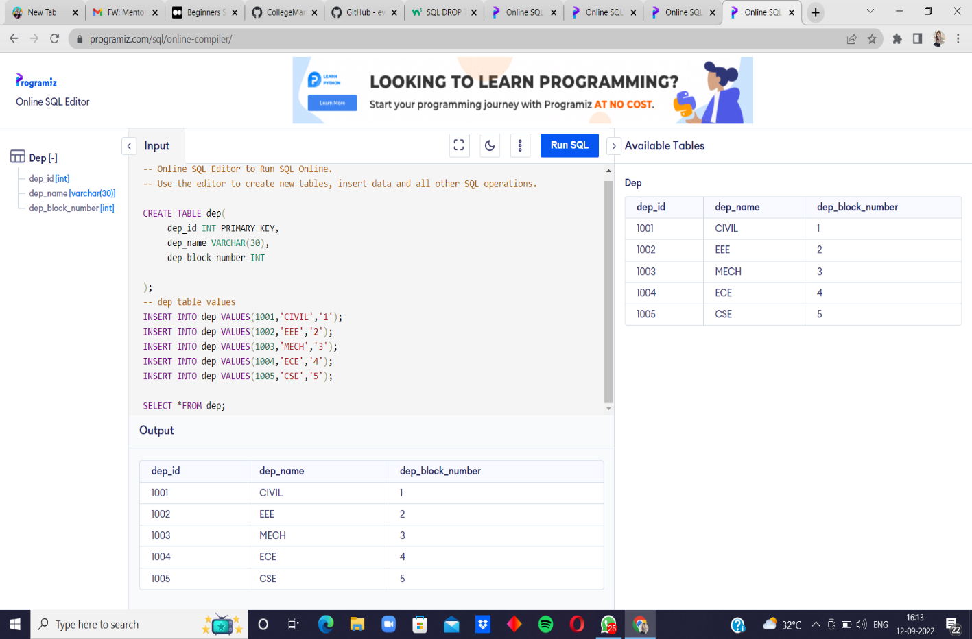

Student:

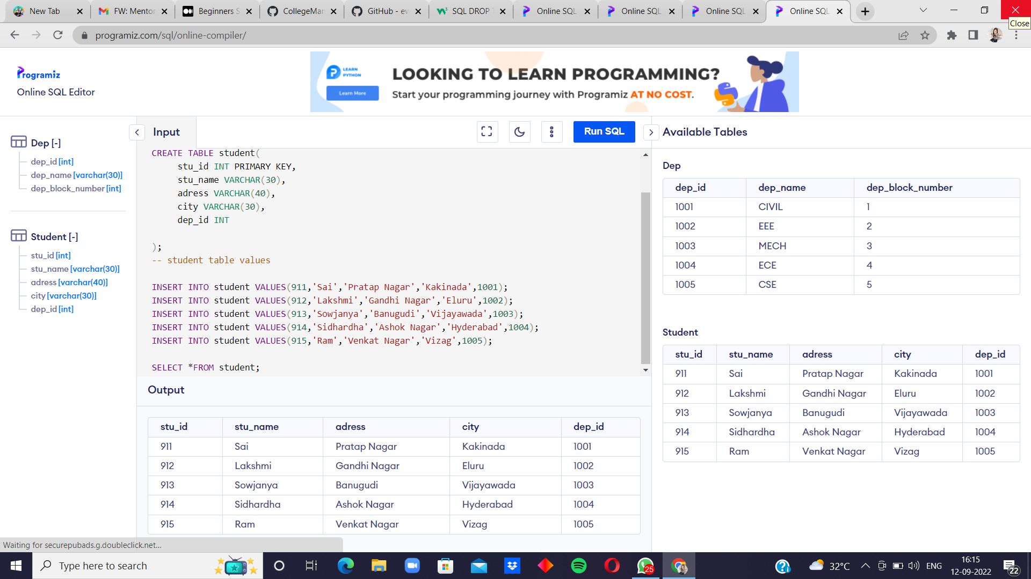

Staff:

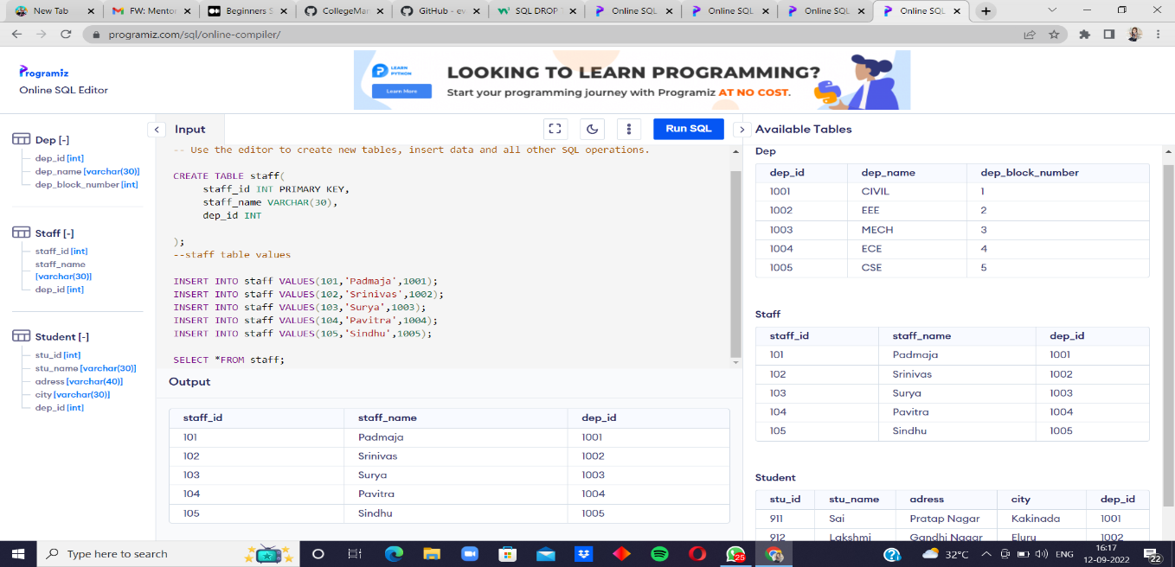

Subject:

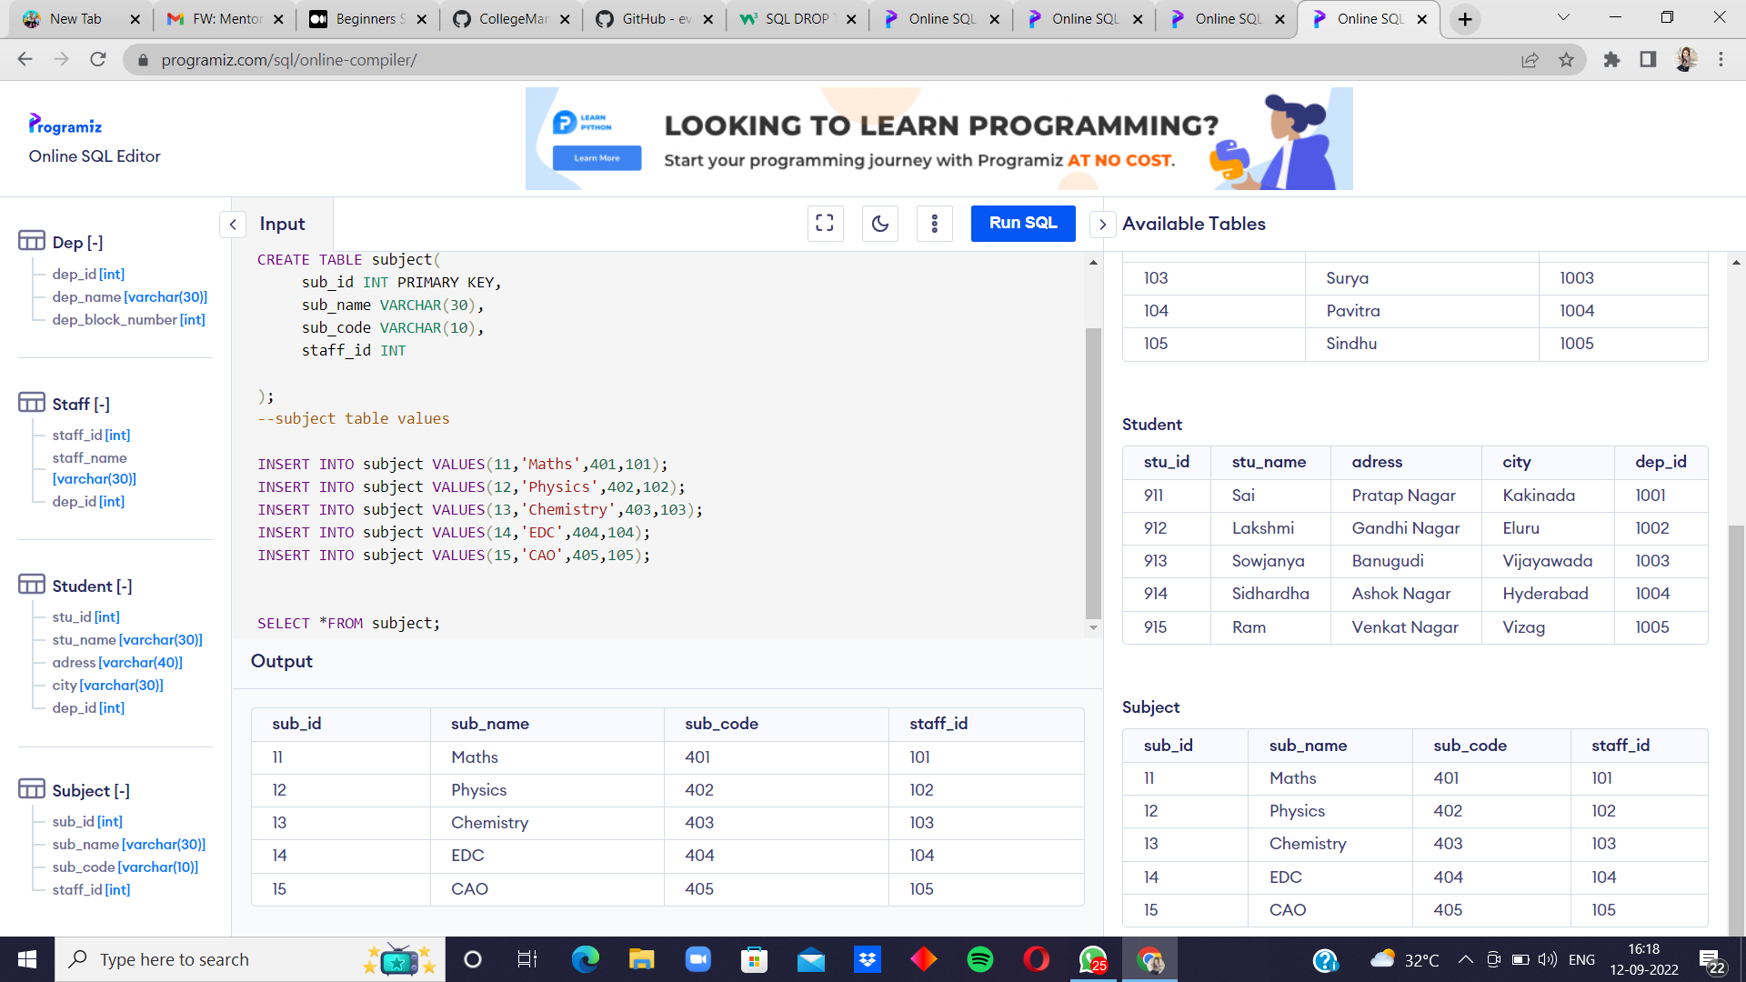

Marks:

